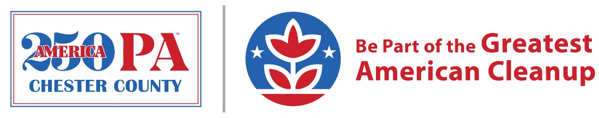
Partner Toolkit
America250 in Chester County
Be part of the Greatest American Cleanup
As our nation prepares to commemorate its 250th anniversary, Keep Chester County Beautiful (KCCB) and the America250PA Chester County Commission (CC250) invite residents, organizations, businesses, and school groups to take part in the Greatest American Cleanup right here in Chester County. Our goal is to have 50 separate volunteer groups participating in beautification activities in Chester County by the end of 2026. Together, we can honor Chester County’s past through service and ensure these places remain welcoming, safe, and beautiful for future generations!
Below you’ll find sample language for sharing on your organization’s website, social media accounts, and elsewhere.
Facebook
Be a part of the Greatest American Cleanup! @KeepChesterCountyBeautiful and @Chesco250 are looking for 50 volunteer groups to take part in beautification efforts across #Chesco by the end of 2026 in honor of America’s 250th. Learn how you can get involved: https://www.chescoplanning.org/Environmental/KCCB/A250.cfm

LinkedIn
Be a part of the Greatest American Cleanup in honor of America’s 250th anniversary of the Declaration of Independence! Keep Chester County Beautiful and the America250PA Chester County Commission (CC250) are calling on 50 volunteer groups (residents, organizations, businesses, school groups, etc.) to participate in beautification efforts across Chester County by the end of 2026. To learn more and find out how to get involved, visit https://www.chescoplanning.org/Environmental/KCCB/A250.cfm.

Twitter
@KeepChesterCountyBeautiful and CC250 are looking for 50 volunteer groups to take part in beautification efforts across #Chesco by the end of 2026 in honor of America’s 250th. Get involved: https://www.chescoplanning.org/Environmental/KCCB/A250.cfm

Instagram
Be part of the Greatest American Cleanup!
@KeepChesterCountyBeautiful and @Chesco250 are calling on 50 volunteer groups to take part in beautification efforts across #Chesco by the end of 2026 in celebration of America’s 250th. Whether you’re a resident, organization, business, school or other group, you can get involved! Find out how at chescoplanning.org/Environmental/KCCB/A250.cfm.

Newsletters/Other
Be Part of the Greatest American Cleanup
In honor of America’s 250th anniversary, Keep Chester County Beautiful and the America250 Chester County Commission (CC250) are calling on 50 volunteer groups to participate in beautification efforts across Chester County by the end of 2026. Residents, organizations, businesses, schools and other groups are invited to take part in cleanups, plantings, and other beautification activities that help make a lasting impact while celebrating this historic milestone. To learn more and find out how you can get involved, visit https://www.chescoplanning.org/Environmental/KCCB/A250.cfm.

